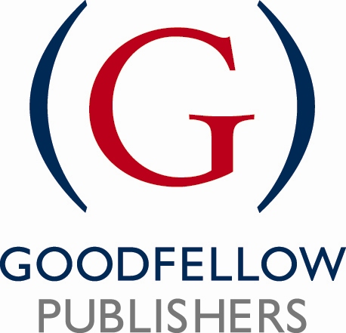

**Project Proposal Form**

**Please complete the questions below including as much detail as possible. This document will be used to give us an initial indication of the project, its outline and it’s potential. Please be aware that this is the document likely to be sent out for double blind review, so bear in mind that it needs to include all important information that reviewers would need to consider.**

**NB. by using the term 'project' throughout, we mean hard copy book, online product or multimedia mix.**

**Many thanks for sending us your proposal.**

Type into the right hand column, which will expand as you type where necessary.

Date:

|  |  |
| --- | --- |
| **SUGGESTED TITLE**  **AND SUB TITLE** |  |
| **AUTHOR(S) AND/OR EDITORS**  **DETAILS**  Include email and postal addresses and telephone contact details (in the event of sending this document out for review, we will remove this detail).    Where possible, please also attach a brief CV, including relevant career details, present appointment, and a full list of previous publications and anything due for publication. You may wish to send this as a separate attachment. |  |
| **DESCRIBE THE INTENDED MARKET(S)/AUDIENCE**   * Define as accurately as possible the target audience. Indicate primary and secondary markets, and for a practitioner audience please list the relevant job titles/functions. * If it has academic appeal, where possible list the qualifications for which the project will be recommended for use. Include typical course titles and levels of study. * Will it have an international appeal? |  |
| **PROPOSED CONTENTS**  Supply a list of chapters/sections with as much detail as possible, explaining briefly what each will cover. You may put this on a separate sheet, or keep in this document.  Do you have draft/sample material you can send alongside the proposal? Please do not put your contents list into a table; unformatted text is best please. |  |
| **SIZE OF PROJECT & SCHEDULE**  Please indicate the proposed number of words, and the approx number of diagrams. |  |
| **PROPOSED DELIVERY OF COMPLETED MATERIALS**  Please try to be as realistic as possible. Is the published work time sensitive? |  |
| **SUPPLEMENTS**  Detail any supplementary material that you intend to provide for readers (case studies, teaching materials, companion websites). |  |
| **COMPETITION**  List the main competing products, (list author, title, edition, publisher, publication date, price, length) and detail their major strengths and weaknesses. You should list the advantages your proposal will have over each competing title.  If you believe there are no competing works, where do people currently go to find out about this subject? |  |
| **MARKET BENEFITS**  What do you consider the unique selling points of your proposal. Why would people buy it? Think in terms of the marketing blurb for the project…if you were reading it as a consumer, what would make you buy it. It may be helpful to list these as bullet points or write as a combination of text and points. |  |
| **FEATURES & BENEFITS**  List five (or more) major or specific features of your proposal and the best specific examples therein. Please list in order of importance. |  |
| **ADDITIONAL INFORMATION**  Please add any other information that you think might be helpful to us in evaluating your proposal. |  |

Please email your completed proposal as an attachment to:

**Sally North, Publisher  
Goodfellow Publishers Limited  
 Mobile: 07748 635 789  
Email: sally.north@goodfellowpublishers.com  
  
Goodfellow Publishers Limited  
6 Nourse Close Woodeaton Oxford  
OX3 9TJ Registered Company No. 06517764**